Smisli što više načina na koje možeš prijeći rijeku | Za što se koriste rijeke? | Popis aktivnosti za slobodno vrijeme koje možete obaviti u rijeci.

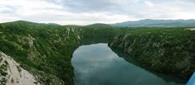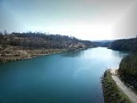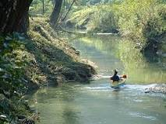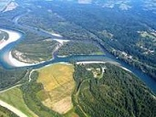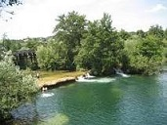

- Otkrij nazive rijeka u Republici Hrvatskoj (uz pomoć zemljovida)

ASAV- _____________ RADVA-________________ VANUD-________________

NJAOL- ____________ RUMA-_______________ LASUT-__________________

NEICTA-___________________ ANJAMRZ-___________________

PUKA-________________ MRENŽICA-__________________

KKAR-______________________ NAU-_________________

ANAKOR-_______________________ NAMIR-______________________

ADOR-_________________ TVARENE-_____________________

ARBOD-_____________________ LATUS-______________________

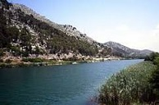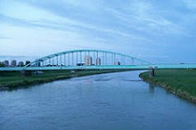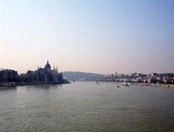

- Ispuni tablicu.

Kako čovjek utječe na rijeke?

DOBRO | LOŠE

- Smisli što bi se moglo napraviti ako rijeka ostane bez vode (presuši)

_______________________________________________________________________

________________________________________________________________________

________________________________________________________________________

________________________________________________________________________

________________________________________________________________________

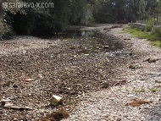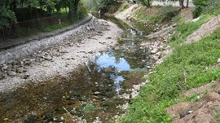

- Smisli što bi se moglo napraviti da rijeka toliko nabuja i dođe do poplave

_______________________________________________________________________

________________________________________________________________________

________________________________________________________________________

________________________________________________________________________

________________________________________________________________________

________________________________________________________________________

